1. Do the below programs in anonymous function & IIFE
   1. Print odd numbers in an array

(function() {

let arr = [12,13,2,32,7,3,45]

arr.forEach((x)=>{

if(x%2!==0)

console.log(x);

})

})()

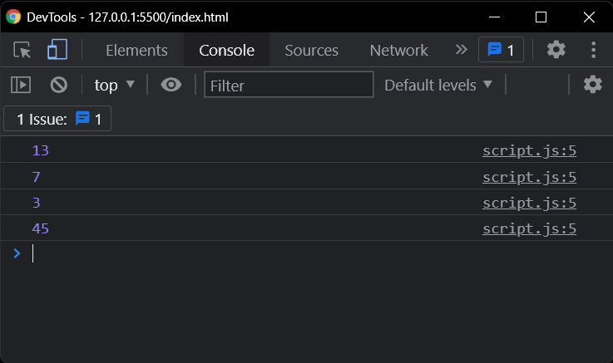

* 1. Convert all the strings to title caps in a string array

let arr = ["Himal","WOW","Guvi","Manthan","pOPOp"];

arr = (function() {

let newarr = []

for (let val of arr) {

val = val.toLowerCase()

newarr.push(val.charAt(0).toUpperCase() + val.slice(1));

}

return newarr;

})();

console.log(arr);

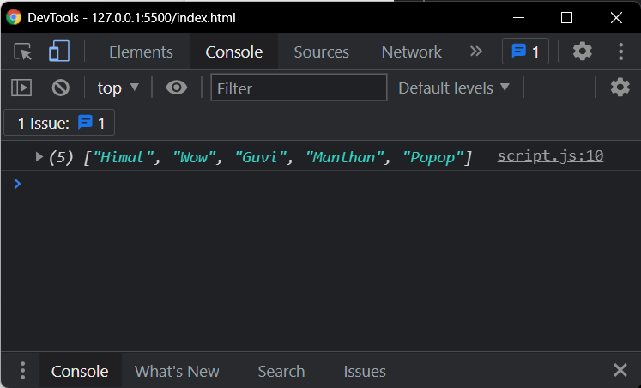

* 1. Sum of all numbers in an array

let arr = [5,2,7,3,3]

let arr_sum = function() {

let sum = 0

arr.forEach((x)=>{

sum += x

})

return sum

}()

console.log(arr_sum)

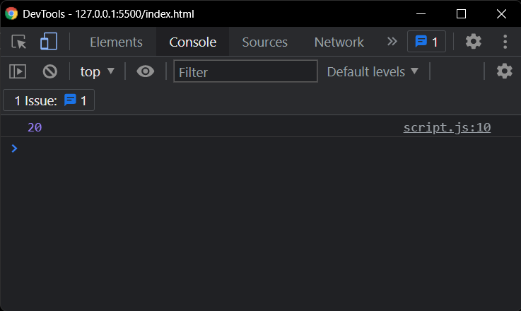

* 1. Return all the prime numbers in an array

let arr = [1,2,3,4,5,6,7,8,9,10,11,12,13,14,15,16];

arr = (function() {

let temp = []

for(let num of arr){

if(num >= 2)

{

let flag = true

for (let k = 2; k < num; k++){

if( num % k == 0)

flag = false;

}

if(flag!==false)

temp.push(num)

}

}

return temp;

})();

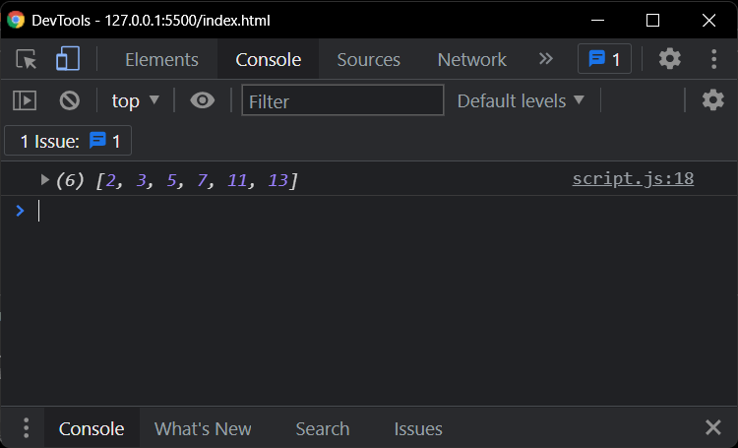

* 1. Return all the palindromes in an array

(function() {

let arr = ["Himal","wow","Guvi","oyo","Manthan","popop"]

arr.forEach((x)=>{

let flag = true

for(let i=0, j=x.length-1; i<x.length/2; i++,j--)

{

if(x[i]!==x[j])

{

flag = false

break;

}

}

if(flag === true)

console.log(x)

})

})()

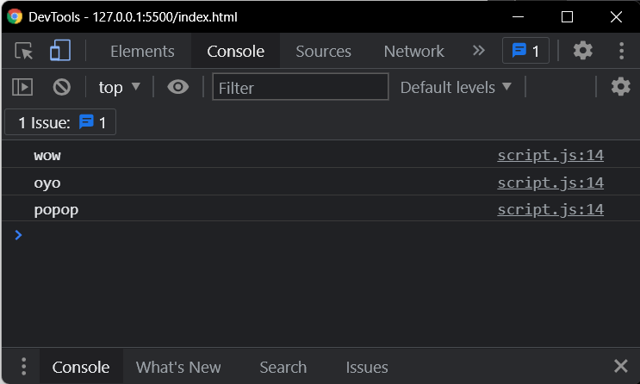

* 1. Return median of two sorted arrays of same size

const array1 = [2, 3, 5, 8];

const array2 = [10, 12, 14, 16, 18, 20];

let median = (arr1,arr2) => {

let arr3 = arr1.concat(arr2);

arr3.sort(function(a, b){return a-b})

if((arr3.length)%2!=0){

return arr3[((arr3.length+1)/2)-1];

}

else{

return (arr3[parseInt((arr3.length-1)/2)] + arr3[parseInt((arr3.length+1)/2)])/2;

}

}

console.log(median(array1,array2))

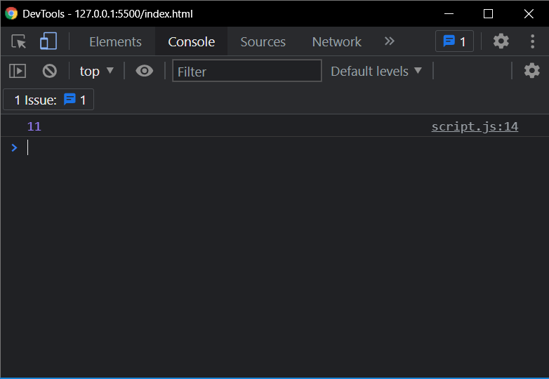

* 1. Remove duplicates from an array

let arr = [1,2,5,3,5,8,6,4,3,1,5,7,8,7,2];

arr = (function() {

let temp = []

for(let num of arr){

let flag = true;

for(let val of temp){

if(val == num){

flag = false;

break

}

}

if(flag){

temp.push(num);

}

}

return temp;

})();

console.log(arr);

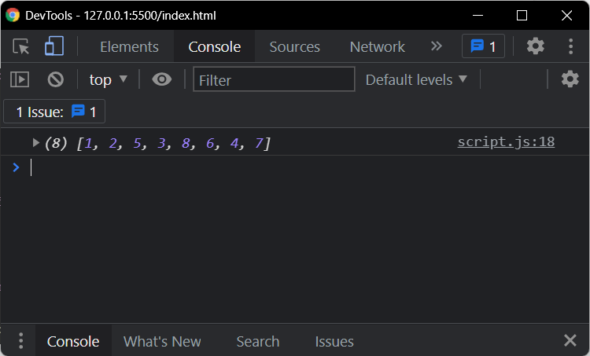

* 1. Rotate an array by k times

let k = 5

let arr = [1,2,3,4,5,6,7,8,9,10,11,12]

let arr_flip = function() {

if(k%2!=0)

for(let i=0, j = arr.length-1; i<arr.length/2;i++,j--) {

[arr[i],arr[j]] = [arr[j],arr[i]]

}

return arr

}()

console.log(arr_flip)

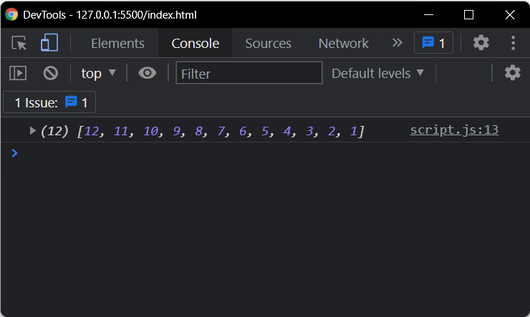

1. Do the below programs in arrow functions
   1. Print odd numbers in an array

let arr = [12,13,2,32,7,3,45]

arr.forEach((x)=>{

if(x%2!==0)

console.log(x);

})

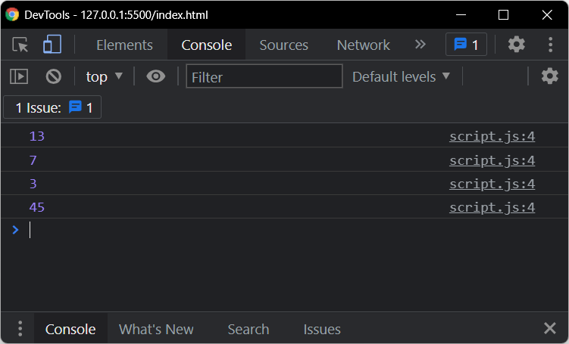

* 1. Convert all the strings to title caps in a string array

let arr = ["Himal","WOW","Guvi","Manthan","pOPOp"];

let i = 0;

arr.forEach((x)=>

{

arr[i] = (x.charAt(0).toUpperCase() + x.toLocaleLowerCase().slice(1));

i++;

})

console.log(arr);

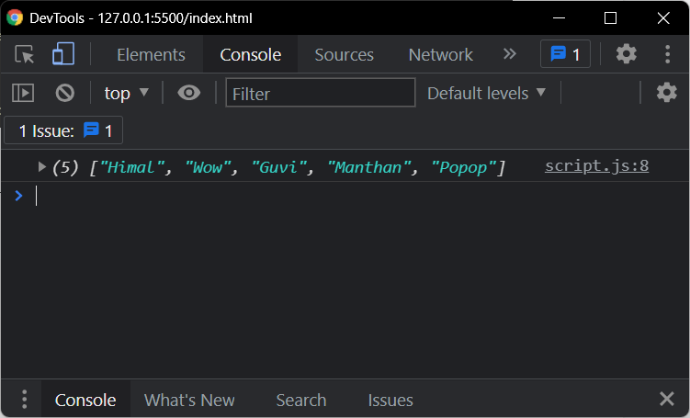

* 1. Sum of all numbers in an array

let arr = [5,2,7,3,3]

let sum = 0

arr.forEach((x)=>{

sum += x

})

console.log(sum)

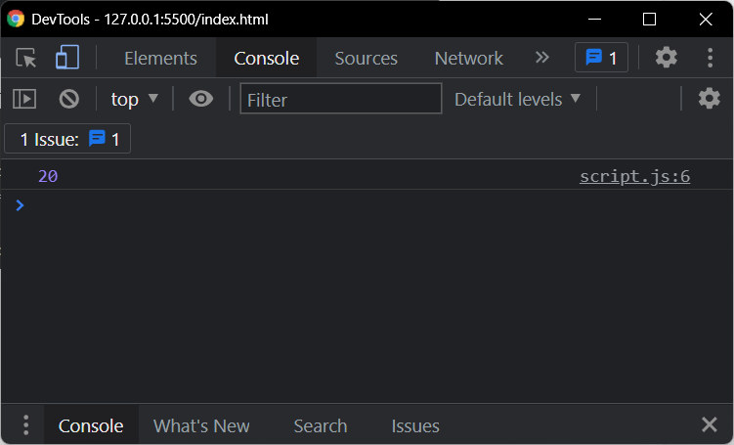

* 1. Return all the prime numbers in an array

let array = [1,2,3,4,5,6,7,8,9,10,11,12,13,14,15,16];

let prime = (arr) => {

let temp = []

for(let num of arr){

if(num >= 2)

{

let flag = true

for (let k = 2; k < num; k++){

if( num % k == 0)

flag = false;

}

if(flag!==false)

temp.push(num)

}

}

return temp;

}

console.log(prime(array));

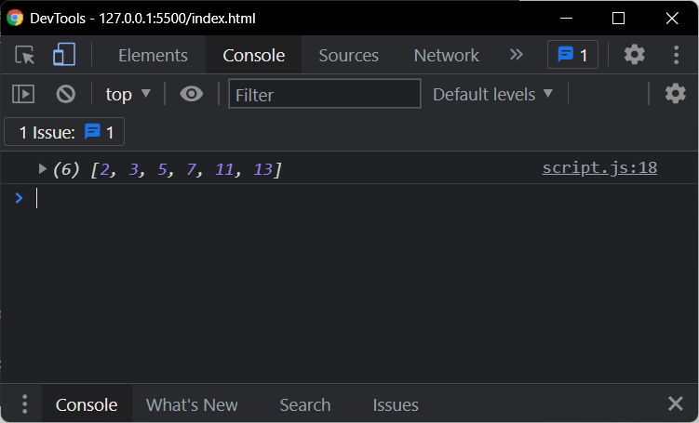

* 1. Return all the palindromes in an array

let arr = ["Himal","wow","Guvi","oyo","Manthan","popop"]

arr.forEach((x)=>{

let flag = true

for(let i=0, j=x.length-1; i<x.length/2; i++,j--)

{

if(x[i]!==x[j])

{

flag = false

break;

}

}

if(flag === true)

console.log(x)

})

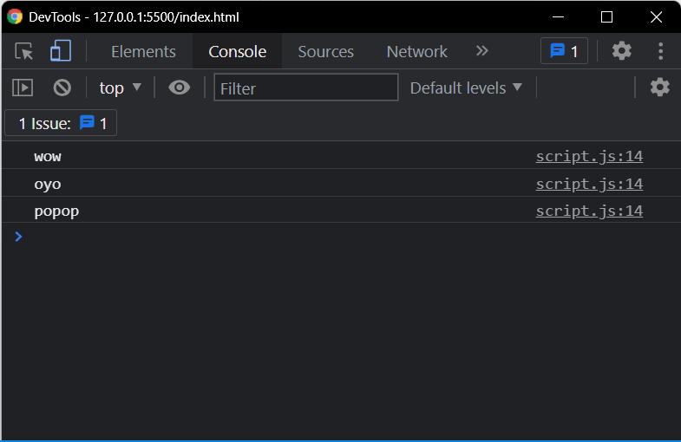

1. <https://medium.com/@reach2arunprakash/guvi-zen-class-javascript-warm-up-programming-problems-15973c74b87f>

/*Problem 1.:

Write a function called “addFive”.

Given a number, “addFive” returns 5 added to that number.*/

var num = 10;

function addFive(num) {

return num+=5

}

var result = addFive(num)

console.log(result);

console.log(addFive(5));

console.log(addFive(0));

console.log(addFive(-5));

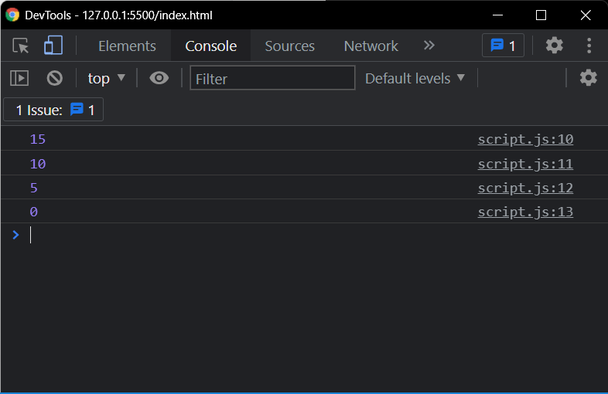

/*Problem 2:

Write a function called “getOpposite”.

Given a number, return its opposite*/

var num = 5;

function getOpposite(num) {

return num *= -1

}

var result = getOpposite(num)

console.log(result);

console.log(getOpposite(5));

console.log(getOpposite(0));

console.log(getOpposite(-5));

// console.log(getOpposite(“5a”)); invalid not a number

console.log(getOpposite(5.5));

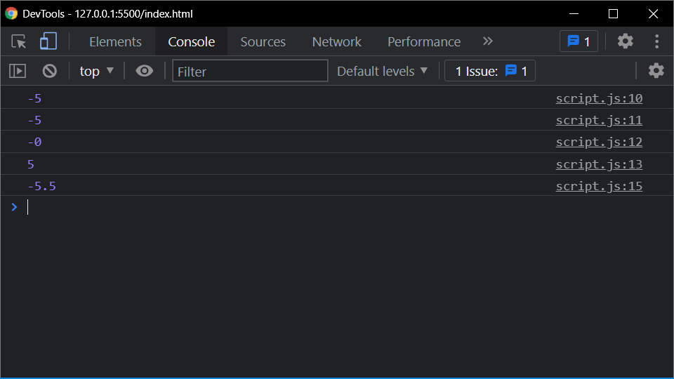

/*Problem 3:

Fill in your code that takes an number minutes and converts it to seconds.*/

var min = 5;

function toSeconds(min) {

return min*60

}

var secs = toSeconds(min)

console.log(secs);

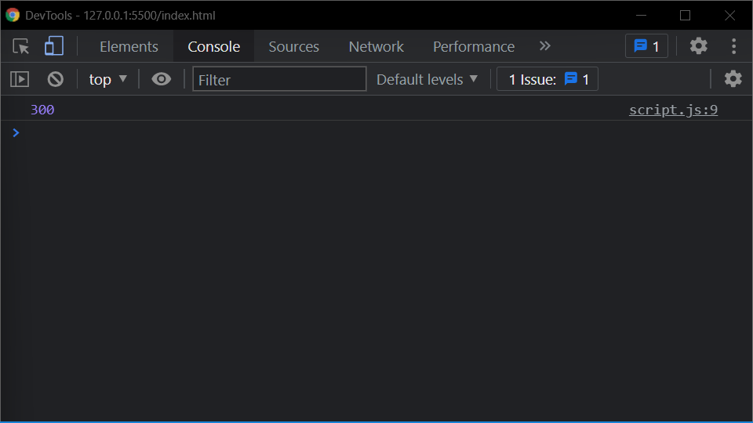

/*Problem 4:

Create a function that takes a string and returns it as an integer*/

var mystr = "5";

function toInteger(mystr) {

return parseInt(mystr)

}

var myint = toInteger(mystr)

console.log(myint);

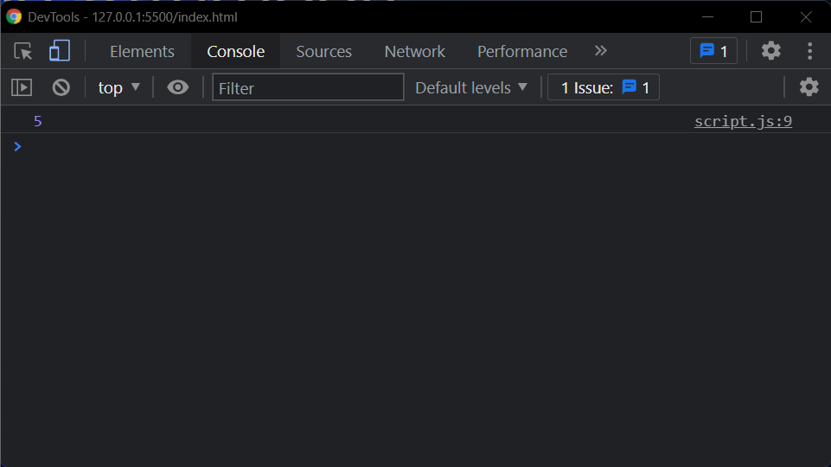

/*Problem 5:

Create a function that takes a number as an argument, increments the number by +1 and returns the result.*/

var myint = 0;

function nextNumber(myint) {

return ++myint

}

var myNextint = nextNumber(myint)

console.log(myNextint);

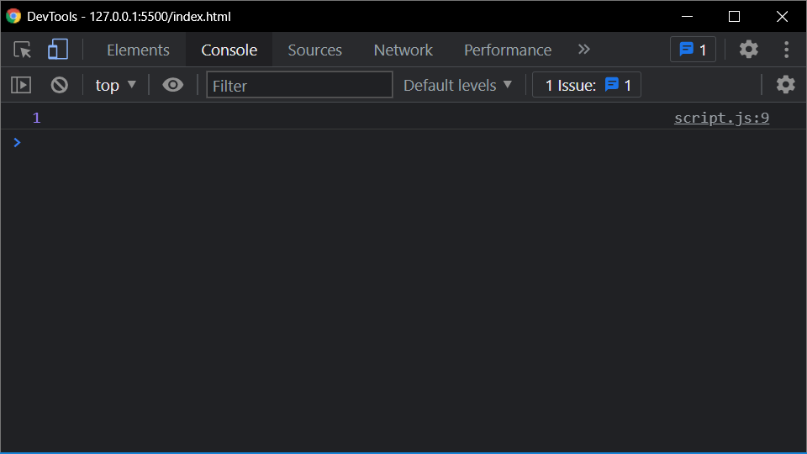

/*Problem 6:

Create a function that takes an array and returns the first element..*/

var arr = [1, 2, 3];

function getFirstElement(arr) {

return arr[0]

}

var data = getFirstElement(arr)

console.log(data);

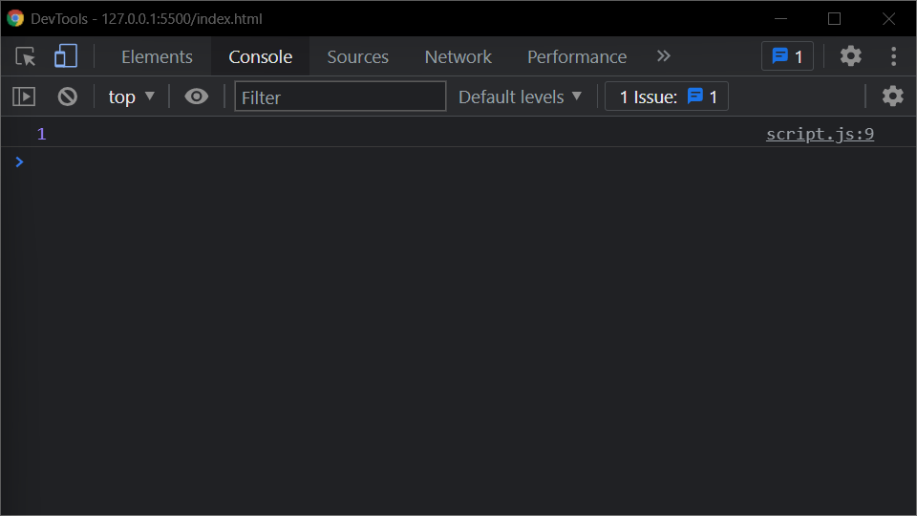

/*Problem 7:

Convert Hours into Seconds

Write a function that converts hours into seconds*/

var arr = [1, 2, 3];

function hourToSeconds(arr) {

for (var i = 0; i < arr.length; i++) {

arr[i] *= 3600

}

return arr

}

var data = hourToSeconds(arr)

console.log(data);

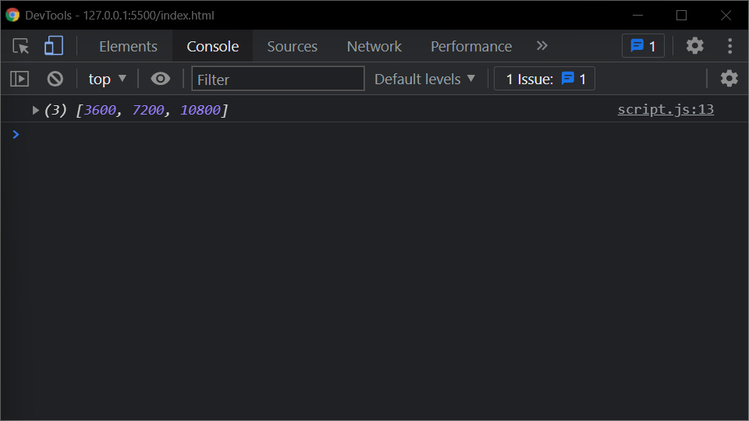

/*Problem 8:

Find the Perimeter of a Rectangle

Create a function that takes height and width and finds the perimeter of a rectangle.*/

function findPerimeter(num1,num2) {

return num1*2 + num2*2

}

var peri = findPerimeter(6,7)

console.log(peri);

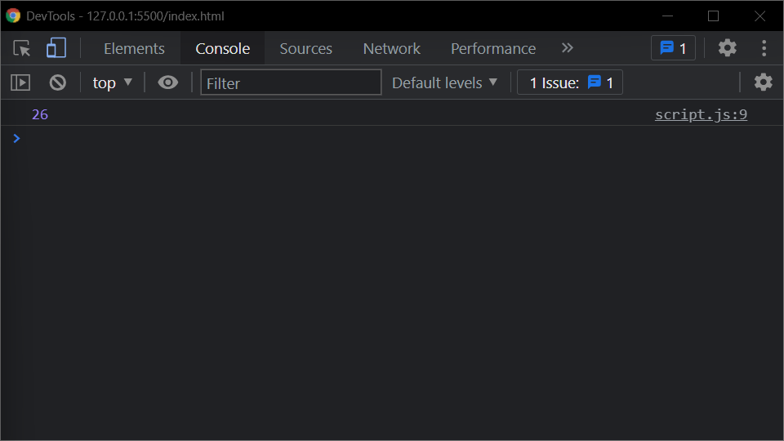

/*Problem 9:

Less Than 100?

Given two numbers, return true if the sum of both numbers is less than 100. Otherwise return false*/

function lessThan100(num1,num2) {

if((num1+num2)<100)

return true;

return false;

}

var res = lessThan100(22,15)

console.log(res);

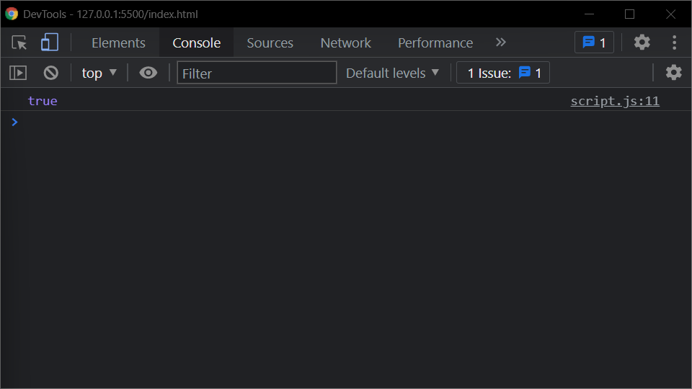

/*Problem 10:

There is a single operator in JavaScript, capable of providing the remainder of a division operation. Two numbers are passed as parameters. The first parameter divided by the second parameter will have a remainder, possibly zero. Return that value.*/

function remainder(num1,num2) {

return num1%num2

}

var res = remainder(1,3)

console.log(res);

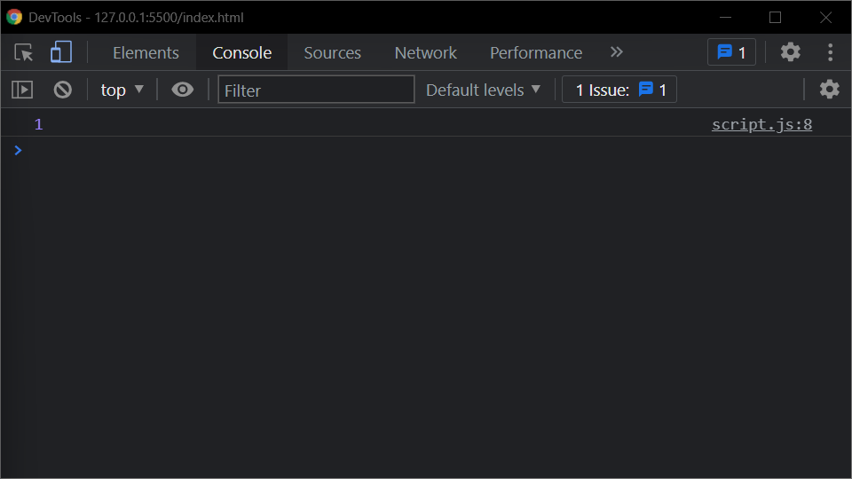

/*Problem 11:

Old macdonald had a farm:

MacDonald is asking you to tell him how many legs can be counted among all his animals. The farmer breeds three species:

turkey = 2 legs

horse = 4 legs

pigs = 4 legs

The farmer has counted his animals and he gives you a subtotal for each species. You have to implement a function that returns the total number of legs of all the animals.*/

function CountAnimals(tur,horse,pigs) {

return tur*2 + horse*4 + pigs*4

}

var legs = CountAnimals(2,3,5)

console.log(legs);

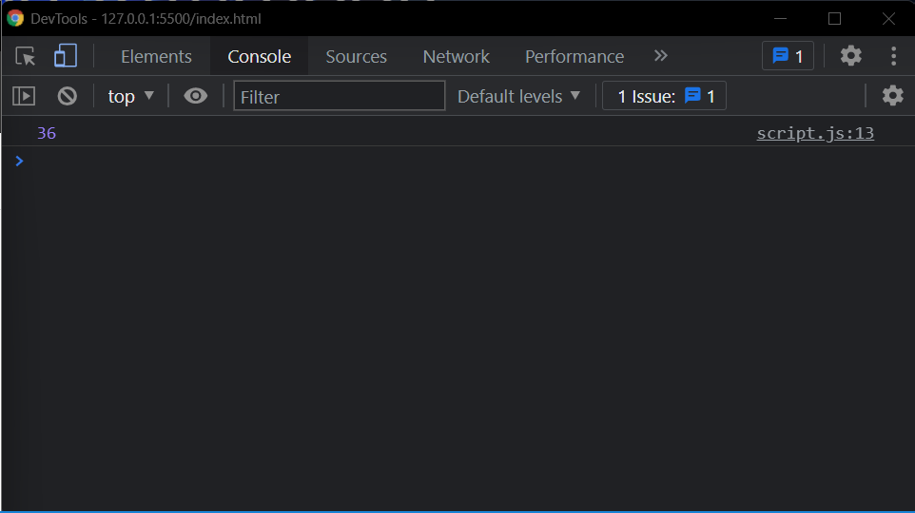

/*Problem 12:

Frames Per Second

Create a function that returns the number of frames shown in a given number of minutes for a certain FPS.*/

function frames(num1,num2) {

return num1*num2*60

}

var fps = frames(1,2)

console.log(fps);

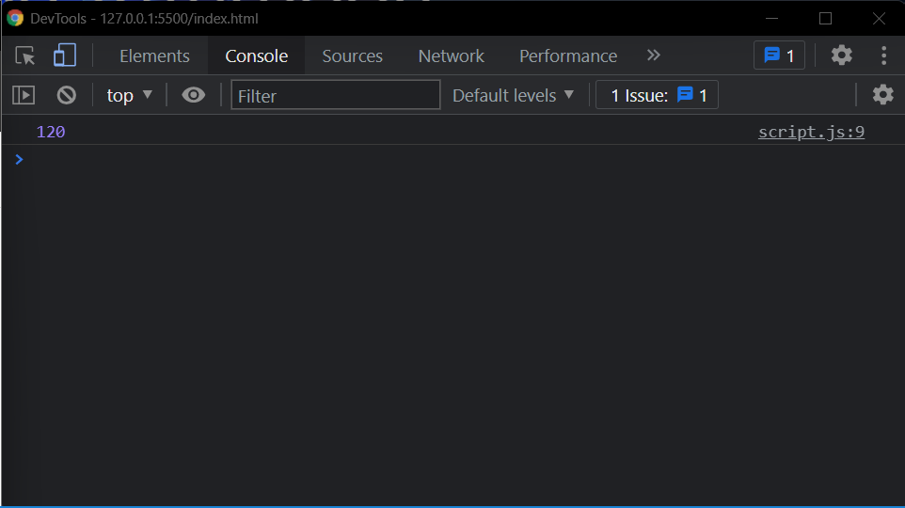

/*Problem 13:

Check if an Integer is Divisible By Five

Create a function that returns true if an integer is evenly divisible by 5, and false otherwise.

*/

function divisibleByFive(num1) {

if(num1%5==0)

return true

return false

}

var divisible = divisibleByFive(5)

console.log(divisible);

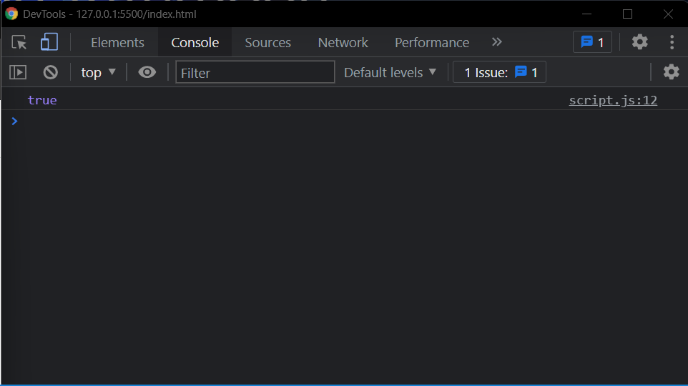

/*Problem 14:

Write a function called “isEven”.

Given a number, “isEven” returns whether it is even

*/

function isEven(num){

if(num%2==0)

return true;

return false

}

var even = isEven(5)

console.log(even);

console.log(isEven(12));

console.log(isEven(0));

console.log(isEven(11));

console.log(isEven("11h"));

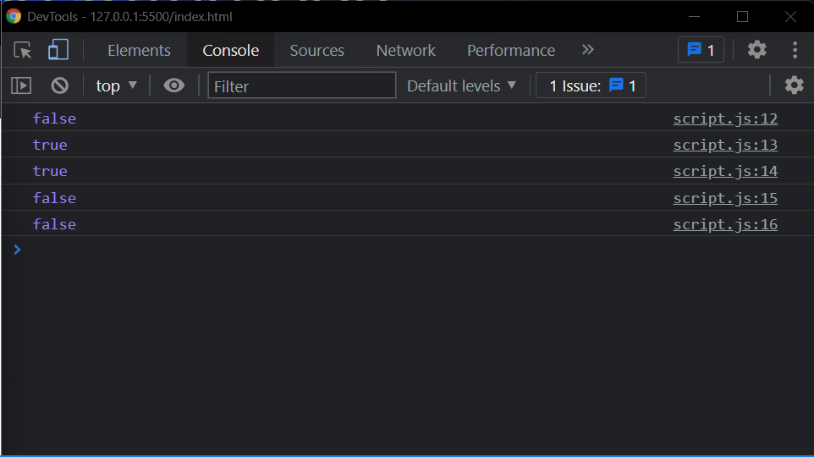

/*Problem 15:

Write a function called “areBothOdd”.

Given 2 numbers, “areBothOdd” returns whether or not both of the given numbers are odd.

*/

function areBothOdd(num1, num2){

if(num1%2!=0 && num2%2!=0)

{

console.log("true");

return;

}

console.log("false");

}

areBothOdd(1, 3);

areBothOdd(1, 4);

areBothOdd(2, 3);

areBothOdd(0, 0);

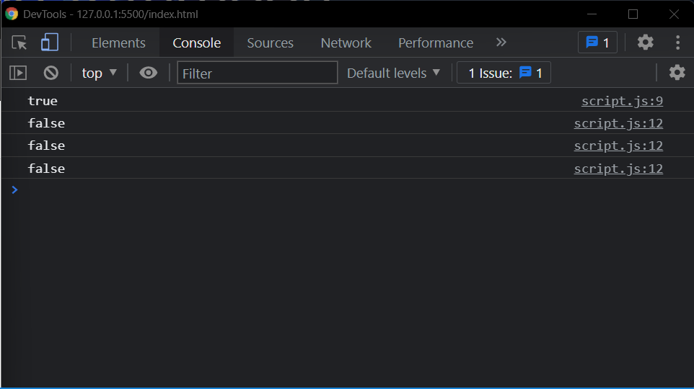

/*Problem 16:

Write a function called “getFullName”.

Given a first and a last name, “getFullName” returns a single string with the given first and last names separated by a single space.

*/

function getFullName(firstName, lastName){

console.log(firstName + ' ' + lastName);

}

getFullName("GUVI", "GEEK");

getFullName("GUVI", "");

getFullName("", "GEEK");

getFullName("", "");

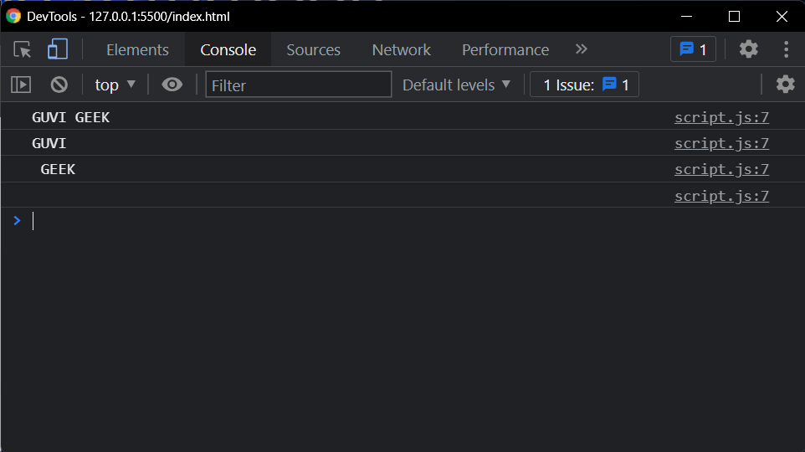

/*Problem 17:

Write a function called “getLengthOfWord”.

Given a word, “getLengthOfWord” returns the length of the given word.

*/

function getLengthOfWord(word1){

if(typeof word1==="string"){

console.log(word1.length);

}

else

console.log(-1)

}

getLengthOfWord("GUVI");

getLengthOfWord("");

getLengthOfWord(9);

getLengthOfWord();

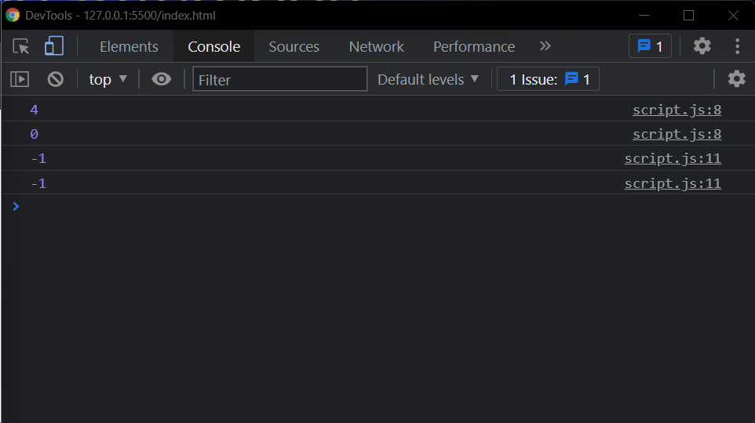

/*Problem 18:

Write a function called “isSameLength”.

Given two words, “isSameLength” returns whether the given words have the same length.

*/

function isSameLength(word1, word2){

if(word1.length == word2.length)

console.log("true")

else

console.log("false")

}

isSameLength("GUVI", "GEEK");

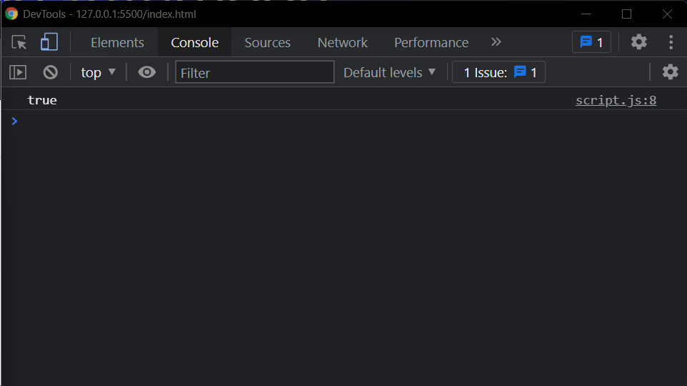

/*Problem 19:

Create a function to calculate the distance between two points defined by their x, y coordinates

*/

console.log(getDistance(100, 100, 400, 300));

function getDistance(x1, y1, x2, y2)

{

return (Math.sqrt(Math.pow(x2 - x1, 2) +

Math.pow(y2 - y1, 2) * 1.0)).toFixed(4);

}

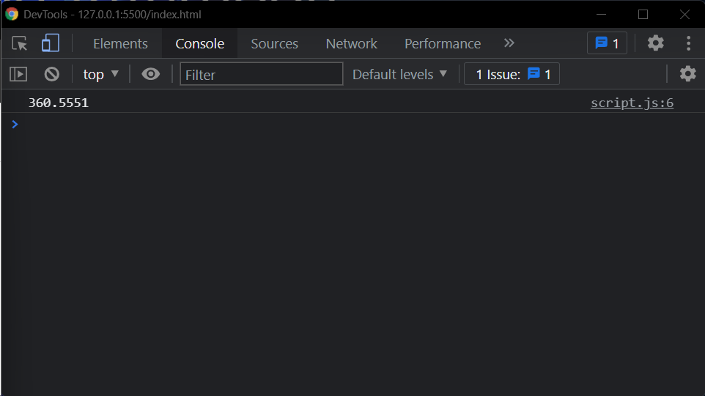

/*Problem 20:

Write a function called “getNthElement”.

Given an array and an integer, “getNthElement” returns the element at the given integer, within the given array. If the array has a length of 0, it should return ‘undefined’.

*/

function getNthElement(array,n){

if(array.length!=0)

return array[n];

return undefined;

}

console.log(getNthElement([1, 3, 5], 1));

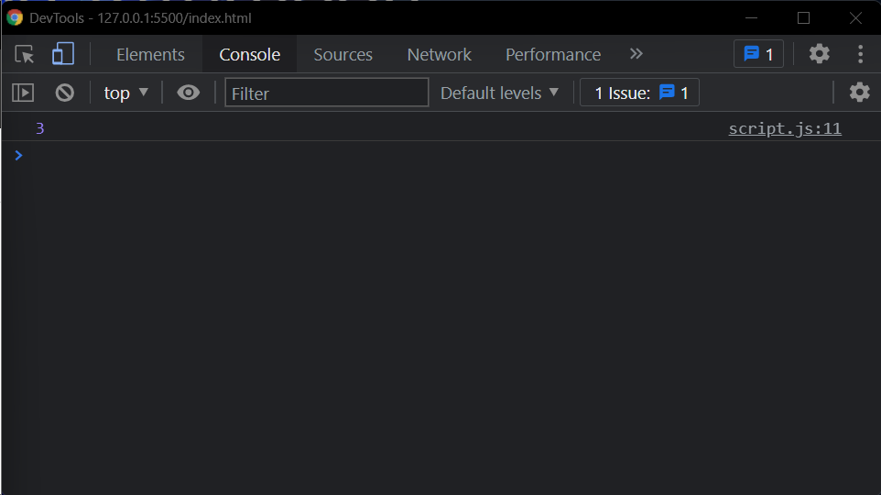

/*Problem 21:

Write a function called “getLastElement”.

Given an array, “getLastElement” returns the last element of the given array. If the given array has a length of 0, it should return ‘-1’.

*/

function getLastElement(array){

return array[array.length-1]

}

let ans = getLastElement([1, 2, 3, 4]);

console.log(ans);

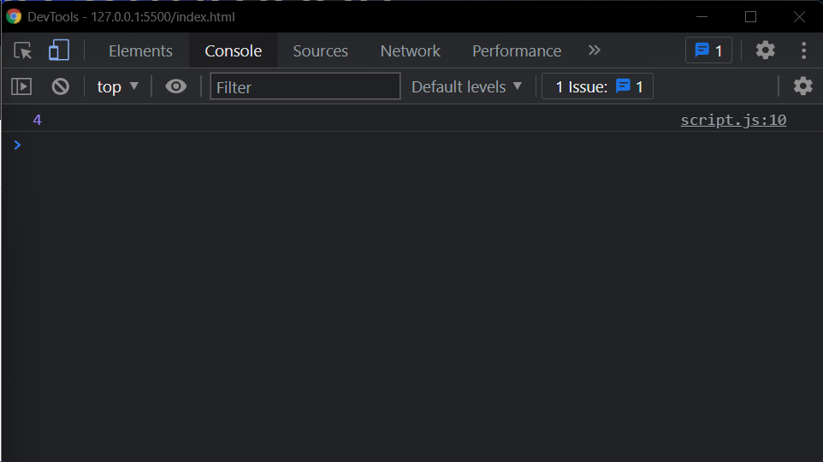

/*Problem 22:

Write a function called “getProperty”.

Given an object and a key, “getProperty” returns the value of the property at the given key. If there is no property at the given key, it should return undefined

*/

var obj = {

mykey: "value",

dummykey: "value2"

};

function getProperty(obj, key) {

console.log(obj[key]);

}

getProperty(obj,"mykey");

getProperty(obj,"dummykey");

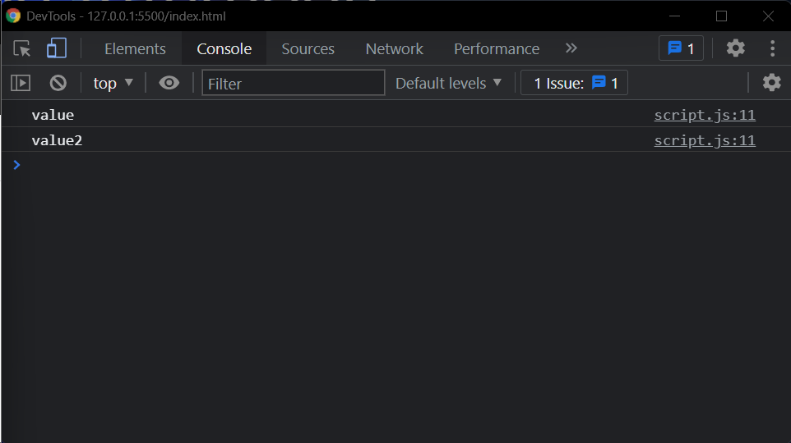

/*Problem 23:

Write a function called “addProperty”.

Given an object and a key, “addProperty” adds a new property on the given object with a value of true.*/

var obj = {

mykey: "value"

};

function addProperty(obj, key){

obj[key] = true;

}

addProperty(obj, "mykey");

console.log(obj)

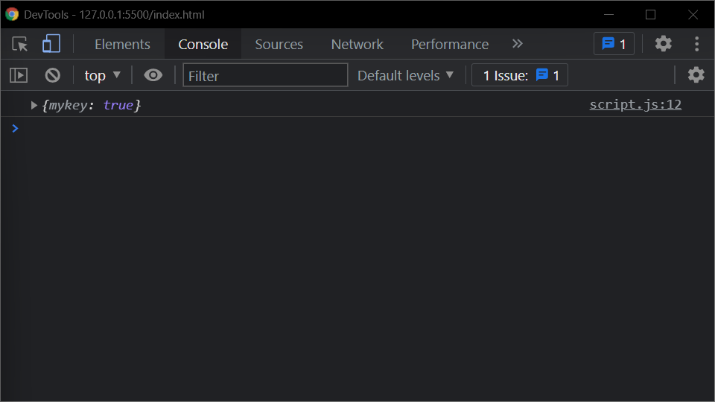

/*Problem 24:

Write a function called “removeProperty”.

Given an object and a key, “removeProperty” removes the given key from the given object.*/

var obj = {

mykey: "value"

};

function removeProperty(obj, key){

delete obj[key];

}

removeProperty(obj, "name");

console.log(obj.name);

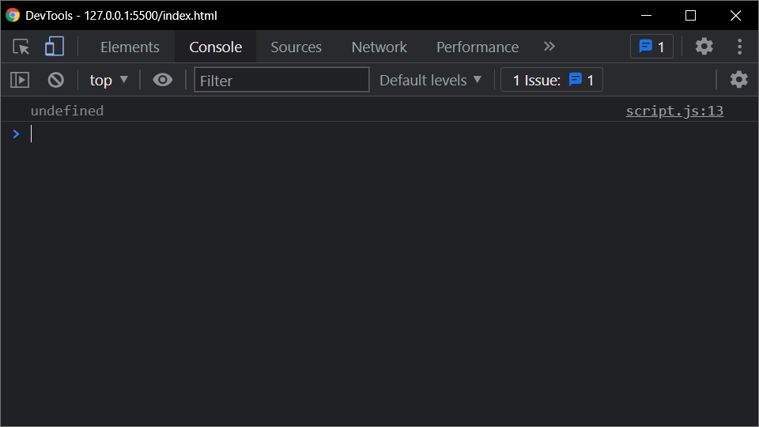

/*Problem 25:

Return an array, where the first element is the count of positives numbers and the second element is sum of negative numbers.

*/

var arr = [-5, 10, -3, 12, -9, 5, 90, 0, 1];

function countPositivesSumNegatives(arr) {

let array = [0,0];

arr.forEach((val)=>

{

if(val<0)

array[1]++;

else

array[0]++;

})

return array;

}

var ar2 = countPositivesSumNegatives(arr)

console.log(ar2);

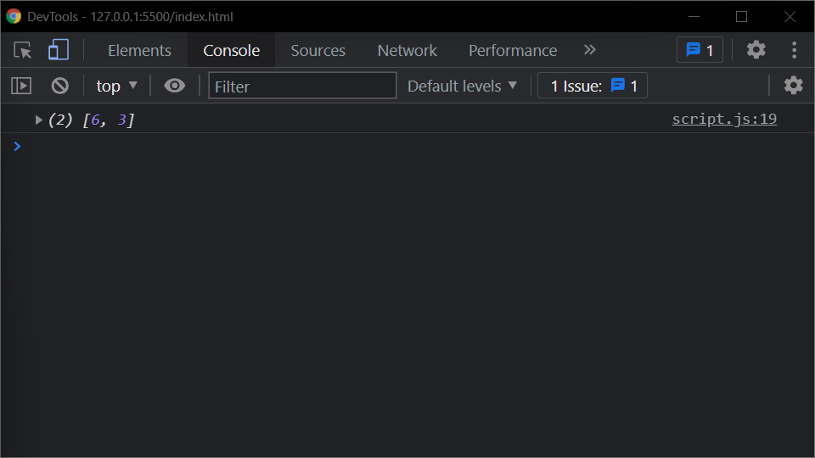

/*Problem 26:

Return an array, where the first element is the count of positives numbers and the second element is sum of negative numbers.

*/

function getPositives(ar){

let array = [];

ar.forEach((val)=>

{

if(val>=0)

array.push(val);

})

return array;

}

var ar = [-5, 10, -3, 12, -9, 5, 90, 0, 1];

var ar2 = getPositives(ar);

console.log(ar2);

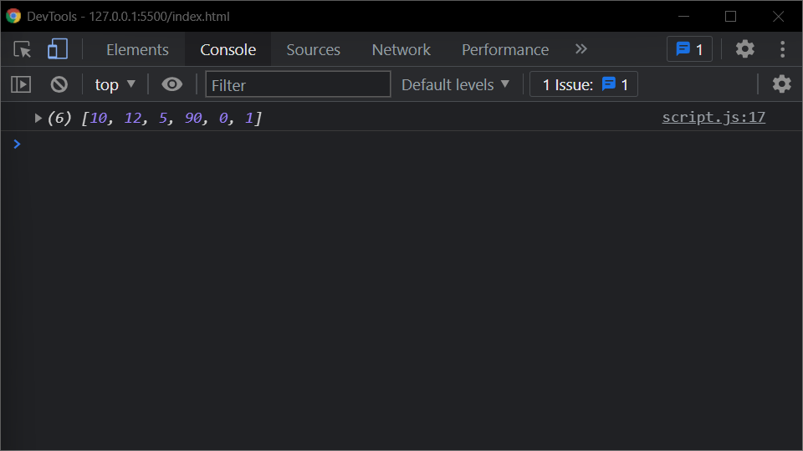

/*Problem 27:

Write a function `powersOfTwo` which will return list of all powers of 2 from 0 to n (where n is an exponent).

*/

function powersOfTwo(n){

let list = []

for (let i = 0; i <= n; i++)

list.push(Math.pow(2, i));

console.log(list);

}

powersOfTwo(0)

powersOfTwo(1)

powersOfTwo(2)

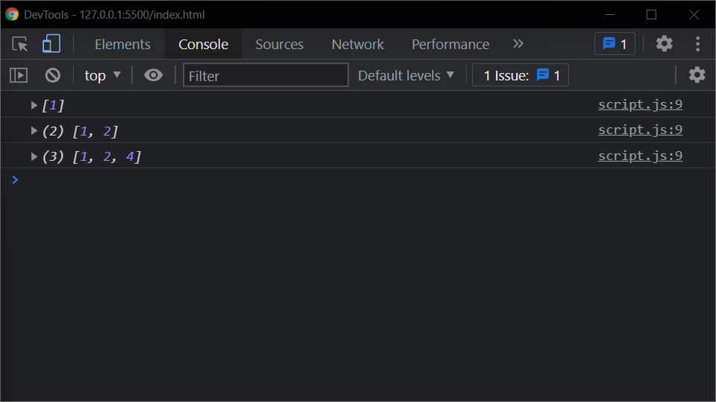

/*Problem 28:

Find the maximum number in an array of numbers

*/

function findMax(ar)

{

return Math.max(...ar)

}

var ar = [-5, 10, -3, 12, -9, 5, 90, 0, 1];

var max = findMax(ar);

console.log("Max: ", max);

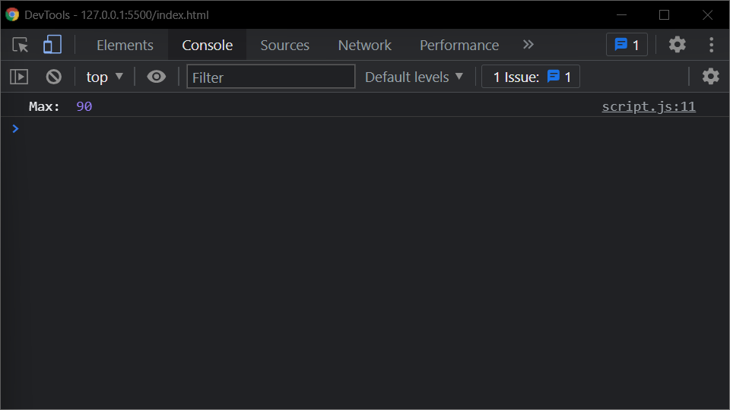

/*Problem 29:

Print the first 100 prime numbers

*/

printPrimes(100);

// Function prints the first nPrimes numbers

function printPrimes(nPrimes)

{

var n = 0;

var i = 2;

while(n < nPrimes)

{

if (isPrime(i))

{

console.log(n, " → ", i);

n++;

}

i++;

}

}

// Returns true if a number is prime

function isPrime(num)

{

if(num < 2)

return false

else

{

for (let k = 2; k < num; k++){

if( num % k == 0)

return false

}

return true

}

}

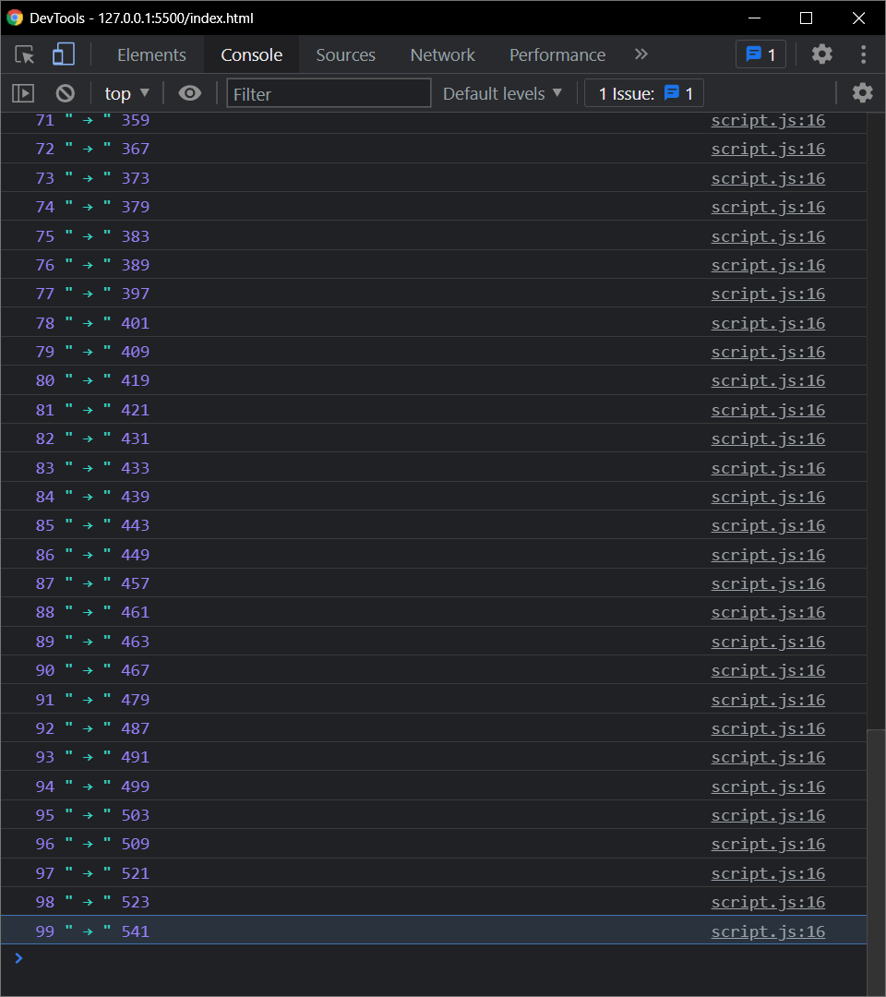

/*Problem 30:

Create a function that will return in an array the first “nPrimes” prime numbers greater than a particular number “startAt”

*/

console.log(getPrimes(10, 100));;

// Function prints the first nPrimes numbers

function getPrimes(nPrimes,StartAt)

{

var n = 0;

var i = StartAt;

let arr = []

while(n < nPrimes)

{

if (isPrime(i))

{

arr.push(i)

n++;

}

i++;

}

return arr;

}

// Returns true if a number is prime

function isPrime(num)

{

if(num < 2)

return false

else

{

for (let k = 2; k < num; k++){

if( num % k == 0)

return false

}

return true

}

}

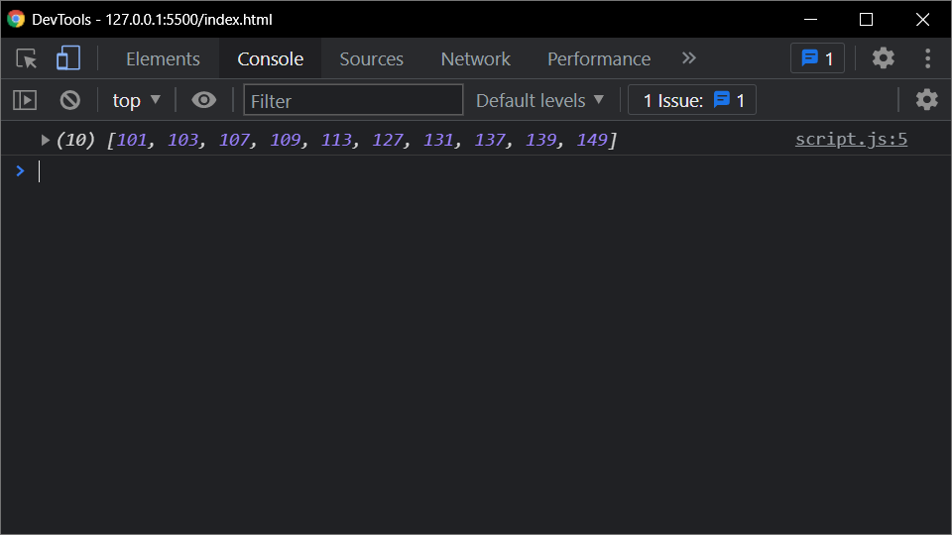

/*Problem 31:

Reverse a string

*/

var s = reverseString("JavaScript");

console.log(s);

function reverseString(s)

{

return s.split("").reverse().join("")

}

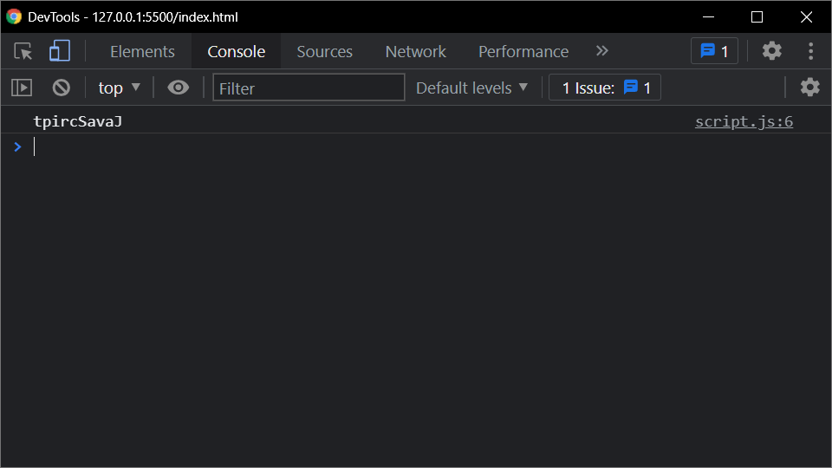

/*Problem 31:

Create a function that will merge two arrays and return the result as a new array

*/

var ar1 = [1, 2, 3];

var ar2 = [4, 5, 6];

var ar = mergeArrays(ar1, ar2);

console.log(ar);

function mergeArrays(ar1, ar2)

{

var result = [];

//this will add the first array to the result array

for(let el of ar1)

{

result.push(el);

}

for(let el of ar2)

{

result.push(el);

}

return result;

}

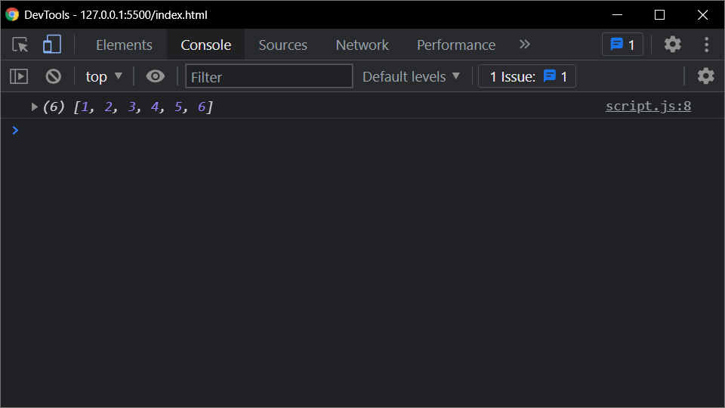

/*Problem 32:

Calculate the sum of numbers received in a comma delimited string

*/

console.log(sumCSV("1.5, 2.3, 3.1, 4, 5.5, 6, 7, 8, 9, 10.9"));

function sumCSV(s)

{

let sum = 0;

let arr = s.split(", ")

for (const val of arr) {

sum += parseFloat(val)

}

return sum;

}

